IUCN Academy of Environmental Law Ten Year Report (2005-2015)
The present document provides background highlights to survey the work of the Academy pursuant to the 2005 agreement with IUCN under which the organization was originally established as a Canadian not-for-profit corporation with its Secretariat at the Faculty of Law, University of Ottawa.
For convenience the report is organized in relation to the areas of academic endeavour to which the Academy was expected to contribute:
- Development of Academic Curricula (p.5)
- Training the Teachers of Environmental Law (p.6)
- Conduct of Colloquia, Conferences, Seminars and other academic meetings (p.7)
- Awards of Diplomas and Certificates (p.9)
- Academic Research (p.10)
- Academic Support Services (p.11)
Appendix 1: Essential Readings in Environmental Law (p.13)
Appendix 2: Criteria for Environmental Law Education Awards, Research Awards and Fellows (p.16)
Appendix 3: IUCN Academy of Environmental Law Publications (p.19)
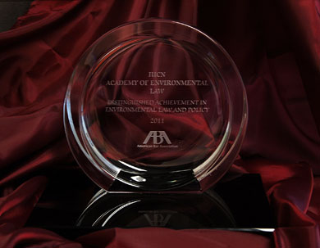
The International Union for Conservation of Nature Academy of Environmental Law (IUCN Academy) received the twelfth annual American Bar Association (ABA) Award for Distinguished Achievement in Environmental Law and Policy. The international achievement award was presented on August 7, 2011 at the ABA Annual Meeting in Toronto, Ontario. - See more at: http://www.iucnael.org/en/news/archive-news?start=14#sthash.eJSQu1lD.dpuf

GOVERNING BOARD MEMBERS 2005-2015
[C] Current
[F] Founding

Africa
Professor Robert Kibugi [C]
University of Nairobi, Kenya
Professor Michael Kidd (2008-12)
University of Kwazulu-Natal, South Africa
Professor Charles Okidi [F]
University of Nairobi, Kenya

Meso-America
Professor Gustavo Alanis Ortega [C]
Universidad Iberoamericana, Mexico
Professor José Juan González Marquez (2008-13)
Metropolitan Autonomous University-Azcapotzalco, Mexico
Professor Rafael Gonzalez Ballar, [F]
Faculty of Law, University of Costa Rica

South America
Professor Jose Rubens Morato Leite [C]
Federal University of Santa Catarina, Brazil
Professor Gilberto Rincon (2008-15)
Centre for Studies in Sustainable Development, Colombia

North Asia
Professor Qin Tianbao
Wuhan University, China
Professor Wang Xi (Vice-Chair) (2009-15)
Shanghai Jiao Tong University, China

South-East Asia
Professor Lye Lin Heng [C]
National University of Singapore, Singapore
Professor Gloria Estenzo Ramos (2014-5)
University of Cebu, Philippines
Professor Lye Lin Heng (2007-13) [F]
National University of Singapore, Singapore

South and West Asia
Professor Amber Pant [C]
Tribhuvan University, Nepal
Professor Bharat H. Desai (2009-15)
Jawaharlal Nehru University of India, India

North America and Caribbean
Professor Melissa Powers [C]
Lewis & Clark Law School, USA
Professor Benjamin Richardson (2010-12)
Osgoode Hall Law School, York University, Canada
Professor David Hodas (2008-09)
Widener University, USA
Professor Nicholas Robinson, (Past Chair) [F]
Pace University, USA

Eastern Europe and Central Asia
Professor Nilufer Oral (Chair) [C]
Istanbul Bilgi University, Turkey
Professor Irina O. Krasnova (2008-10)
Russian Academy of Justice, Russia

Oceania
Professor Paul Martin [C]
University of New England, Australia
Professor Robert Fowler (Past Chair) (2008-15)
University of South Australia, Australia
Professor Donna Craig [F]
Centre for Environmental Law, Macquarie University, Australia

Western Europe
Professor Elizabeth Kirk (Duputy Chair) [C]
University of Dundee, UK
Professor Marjan Peeters (2008-12)
Maastricht University, TheNetherlands
Professor Jan Jans (2004-07)
European Law Institute, University of Amsterdam, The Netherlands [F]

Ex Officio
Dr. Sheila Abed de Zavala (2008-12)
Chair, IUCN Commission on Environmental Law, Paraguay

Justice Antonio Benjamin [C]
National High Court of Brazil (STJ), Brazil
Chair, World Commission on Environmental Law

Dr. Alejandro Iza [C]
Head, IUCN Environmental Law Programme
Director, IUCN Environmental Law Centre, Germany

Professor Jamie Benidickson [F]
Director, IUCN Academy of Environmental Law
University of Ottawa, Canada

Professor Ben Boer [F]
Director, IUCN Academy of Environmental Law
University of Ottawa, Canada

Professor Yves Le Bouthillier
Director, IUCN Academy of Environmental Law
University of Ottawa, Canada

Professor Heather McLoed-Kilmurray
Director, IUCN Academy of Environmental Law
University of Ottawa, Canada

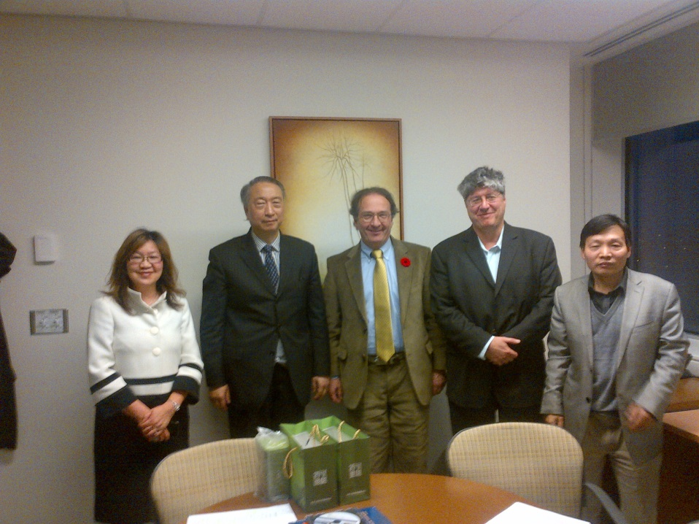

IUCN President Zhang Xinsheng visits the IUCN Academy Secretariat in Ottawa
(L to R: Winnie Carruth, Academy Manager; IUCN Council President Zhang Xinsheng; Jamie Benidickson, Executive Director; Yves Le Bouthillier, Executive Director; Mingde Cao, Visiting Scholar)

(i) Development of Academic Curriculum
The Academy has contributed to the development of environmental law curricula in a variety of ways, drawing upon the expertise available within its broad institutional membership (approximately 190 faculties and departments in roughly 60 countries) and on the basis of partnerships and collaboration with other elements of the IUCN network.
One of the Academy’s earliest projects for UNEP involved the creation of a course or training program on Compliance with and Enforcement of Multinational Environmental Agreements. Under the overall direction of a partner from the Environmental Law Institute in Washington, this project was developed by Academy member scholars in Peru and South Africa with guidance from an international steering committee. The course, consisting of teaching modules, PowerPoints, and an Instructor’s Manual continues to be available online. The project was supportive of the overall objectives of the CEL Specialist Group on Compliance and Enforcement whose chair was instrumental in identifying sources of financial support.
Academy member scholars are currently contributing alongside representatives of the Environmental Law Center, the World Commission on Protected Areas, and the World Commission on Environmental Law to the development of an online series of training modules dealing with Law and Policy for Protected Areas. The project is intended to provide much greater awareness of the substantive analysis and documentation recently published in Guidelines for Protected Areas Legislation (Barbara Lausche and Françoise Burhenne, eds. IUCN Environmental Policy and Law Paper No. 81, 2011). Following a demonstration at the World Parks Congress, the teaching materials, including PowerPoint presentations supported by classroom exercises and guidance for instructors are currently (Winter 2015) being pilot tested. It is anticipated that they will be available in Spring 2015 for use at the graduate and undergraduate levels as well as in the context of professional training. Further promotion is planned for the Academy’s September 2015 Colloquium in Jakarta.
With regard to Climate Law and Sustainable Development Law, Academy member scholars have been collecting sample course outlines and syllabi together with simulated exercises and other classroom support materials in order to make these available to anyone proposing to introduce courses in these fields. A similar initiative is in the early stages of development in the field of Energy Law.
Further support for environmental law learning is provided by a unique service taking the form of Essential Readings in Environmental Law. Leading scholars and specialists have been encouraged to identify key readings and information sources respecting selected areas within the overall environmental law field. Approximately forty five topics are listed in Appendix 1 to this memorandum.

(ii) Training the Teachers:
For the past several years, the Academy has been developing training programs for teachers of environmental law in the developing world. Under the general guidance of Prof. Rob Fowler, a former Chair of the Academy, and Professor Ben Boer, TTT programs were delivered in Wuhan, China, in 2011 and Chongqing in 2013 in close partnership with the University of Vermont Law School. The programs emphasize issues of methodology with reference to selected case studies in which participants simultaneously explore subject matter and distinctive approaches to teaching/ learning.
The Academy is now working with the Asian Development Bank and with administrative assistance from the IUCN Asia office to deliver dedicated TTT programs in the Asia-Pacific region. ADB has identified a number of countries in the region as areas in immediate need of support and it is anticipated that the initiative will expand beyond the 2015 program which involves week-long programs in the Philippines and for the Mekong region.
Sample course materials and a draft manual are available from the Academy Secretariat if further information is required.
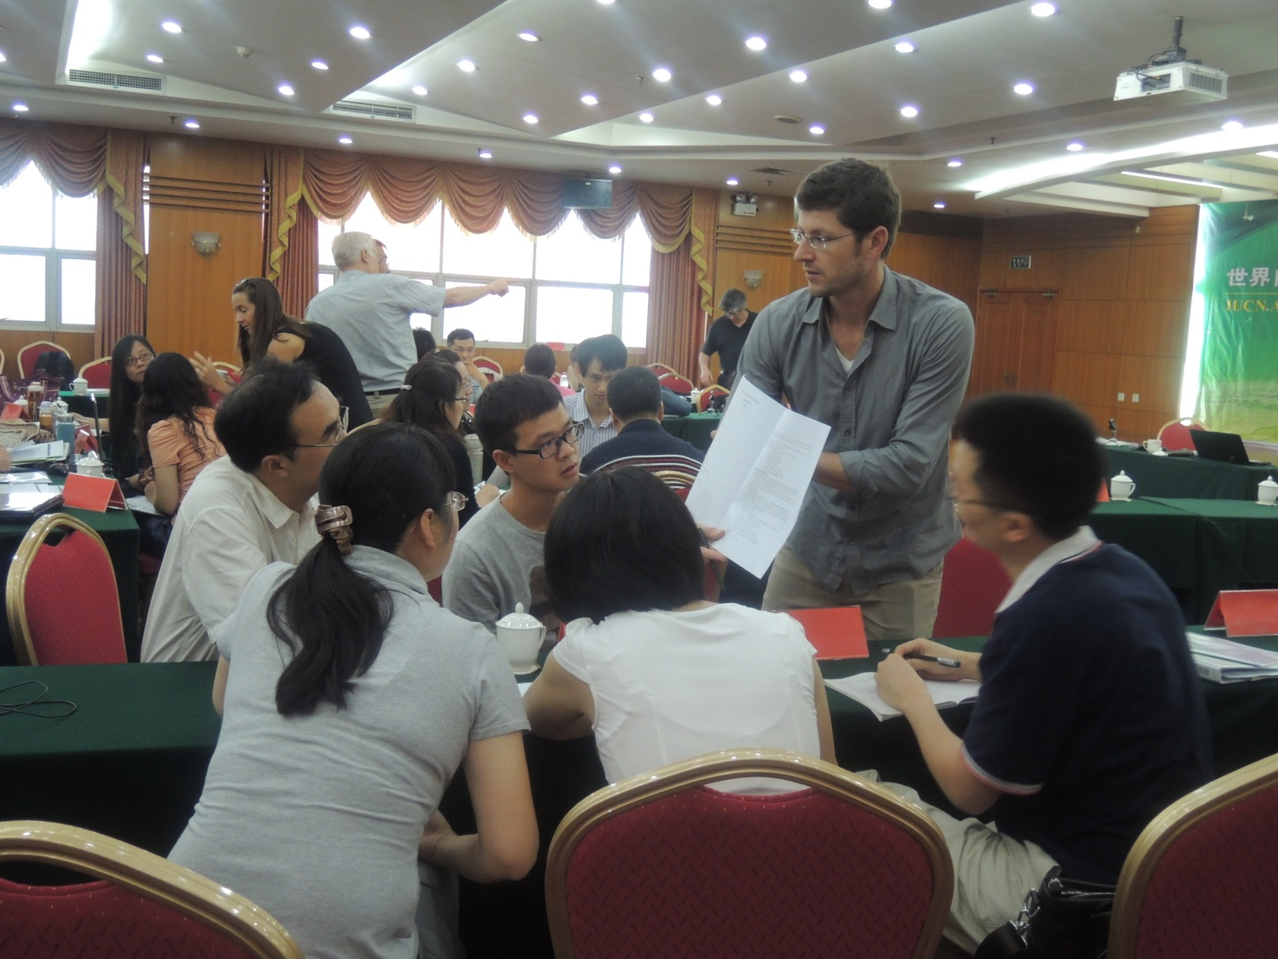
Adam Moser of Vermont Law School and TTT participants, Chongqing, China

(iii) Colloquia, conferences, seminars
The Academy has conducted annual colloquia in different parts of the world from 2003 to the present. Each of these events explores a selected theme or topic within the broad realm of environmental law and takes on its own distinctive character in keeping with the contribution of the host country and institution(s) as selected by the Academy’s Governing Board on the basis of a public “Call to Host Academy Colloquia.” A typical format would involve two pre-colloquium workshops with a day devoted to a discrete research subject (generally selected in collaboration with the Environmental Law Centre) and a day devoted to presentations or workshops on teaching and capacity-building in environmental law. More recently, side events with partner organizations have begun to appear in the program. The Colloquium itself then runs through three days of academic plenary and break-out panel sessions. Most conferences incorporate or are followed by an environmentally-themed Field Trip.
As a general rule, attendance would run between 150 and 200 participants who would in a typical year represent scholars from between thirty-five and forty countries. Subsequent inter-action and collaboration amongst participating scholars underscores the significant contribution made by opportunities for academic inter-action in the field of environmental law.

A full list of colloquia and themes is set out below:
2003 – Shanghai, China (The Law of Energy for Sustainable Development)
2004 – Nairobi, Kenya (Human Habitats and Land Stewardship)
2005 – Sydney, Australia (Biodiversity: Bridging the Divide)
2006 – White Plains, New York, USA (Compliance and Enforcement of Multilateral Environmental Agreements)
2007 – Rio de Janeiro, Brazil (Rio+15: A Legal Critique of Ecologically Sustainable Development)
2008 – Mexico City, Mexico (Poverty Alleviation and Environmental Protection)
2009 – Wuhan, China (Environmental Governance and Sustainability)
2010 – Ghent, Belgium (Linkages Between Biodiversity and Climate Change)
2011 – Eastern Cape, South Africa (Water and the Law: Towards Sustainability)
2012 – Baltimore, Maryland, USA (Global Environmental Law at a Crossroads)
2013 – Hamilton, New Zealand (He Tapuwae: key emerging themes of international, comparative and domestic environmental law and our journey in responding to them)
2014 – Tarragona, Spain (Energy for a Fair Society on a Safe planet)
2015 – Atma Jaya Catholic University, Jakarta, Indonesia (Forest and Marine Biodiversity)
2016 – University of Oslo, Norway (The Environment in Court)
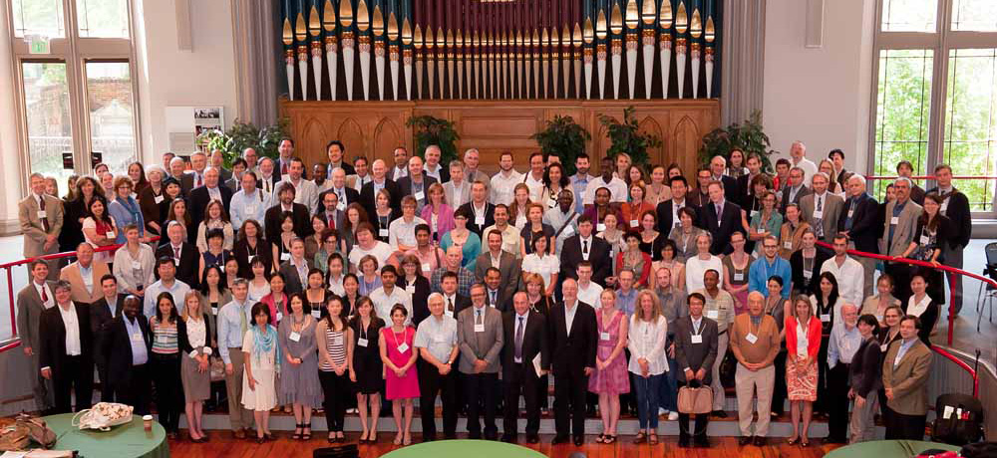
Baltimore, Maryland Colloquium

In addition, the Academy has conducted a number of conferences on more specialized topics over the years. With the support of the IDRC, the Academy convened a conference on needs and opportunities for Environmental Law Research in Ottawa in 2007. On the basis of this gathering the Academy subsequently organized and delivered a major conference on Climate Law and Developing Countries.
In collaboration with Francois Burhenne of the Environmental Law Center and Ben Boer, co-chair of the CEL/WCPA task force on protected areas, the Academy secured financial support from the Social Sciences and Humanities Research Council of Canada to support a conference on Law and Policy for Protected Areas. We understand from participants that this may have been the first occasion on which environmental law scholars with a protected areas focus had ever met together to exchange insights and experience. Many of the case studies initially presented at the Academy’s Protected Areas Conference were subsequently incorporated into Guidelines for Protected Areas Legislation (Barbara Lausche ed. IUCN Environmental Policy and Law Paper No. 81). With support from the Law Foundation of Ontario, the Academy convened a series of international workshops on Biofuels Regulation in Mexico City, Wuhan China, Toronto and Ottawa A resulting publication is expected to appear in 2015 or 2016.
In connection with the annual colloquia, the Academy has regularly partnered with the Environmental Law Center to present research workshops on selected themes of shared interest. Topics for these sessions have included Integrating Human Rights and Environmental Protection; Towards the Legal Recognition and Governance of Ecosystem Services; Ecosystem Services, Economic Valuation, and Environmental Equity: Complementary or Contradictory; and Environmental Law: Scholarship on Effective Implementation. Academy Member Institutions, with various levels of support and participation from the Secretariat have taken the initiative in holding specialized workshops and symposia oriented generally around the participation of Academy member scholars: Such activities have taken place at : Centre for Sustainable Development Studies (CEID), Colombia; University of Groningen, Netherlands;University of Maastricht, Netherlands; Université de Rennes 1, France; University of British Columbia, Canada; Jindal Global Law School, India.
(iv) Awards of Diplomas and Certificates
Participants in the Training the Trainers programs have received certificates upon completion of the course.
As one means of supporting and encouraging Environmental Law Research, the Academy makes an annual award to one Senior Scholar and one Emerging Scholar in the field. These awards are made on the basis of an open nomination process followed by expert review and panel assessment.
To promote and acknowledge excellence in teaching environmental law, the Academy makes annual awards to recognize outstanding contributions to Environmental Law Education to one Senior and one Emerging professor of environmental law.
Distinguished service in the field of environmental law is recognized through the appointment of IUCN Academy Fellows.
Appendix 2 includes further information on eligibility and criteria for these awards and the Fellows designation.

(v) Academic Research
In addition to the research workshops noted above and collaboration with the Environmental Law Center and WCEL, Academy scholars have contributed to a variety of research projects and programs, notably an initiative under the leadership of Prof. Ben Richardson, formerly of the University of British Columbia and now of the University of Tasmania, on climate law and developing countries and on local climate law.
The Academy’s publication program currently consists of a series of edited and peer-reviewed volumes of selected papers presented at each annual colloquia as well as a series of specialized volumes based upon research workshops or special projects. Academy publications are listed in Appendix 3.
In partnership with Edward Elgar publishing and under the general editorship of Prof. Michael Faure, the Academy is developing a multi volume set of reference works styled as the Encyclopedia of Environmental Law. Each volume will be under the direction of a specialist editor or editors and will contain approximately twenty-five short essays prepared by leading experts.
The following volumes are projected for the Encyclopedia of Environmental Law series:
Policy Instruments
Biodiversity and Nature Protection
Trade and Environment
Compliance and Enforcement
Environmental Decision-Making
Water
Climate Change
International Conventions
Human Rights and the Environment
Fundamental Principles
Soils, Wastes and Chemicals
The first volumes are about to enter production with publication expected in 2016.

(vi) Academic Support Services
Through its Teaching and Capacity Building Committee, the Academy has, as mentioned previously, organized regular TCB workshops in conjunction with the annual colloquia. These workshops have provided environmental law teachers with networking opportunities as well as opportunities to exchange knowledge and experience in connection with environmental law teaching methodologies. Sessions have been held for example to address the role of clinical legal education, to discuss the use of technology in environmental law teaching, and long distance and multijurisdictional courses. Discussion is currently underway concerning the use of moot court competitions in the environmental law field.
For the past number of years, the Academy has convened a Graduate Students Forum to provide opportunities for young scholars in the environmental law field to meet together and to benefit from presentations on selected topics. Some of these sessions have addressed questions relating to academic and professional career opportunities, while other sessions have provided guidance on writing and the publication process. A number of senior scholars within the Academy have been invited to participate in those sessions over the years. More than 30 graduate students usually take part.
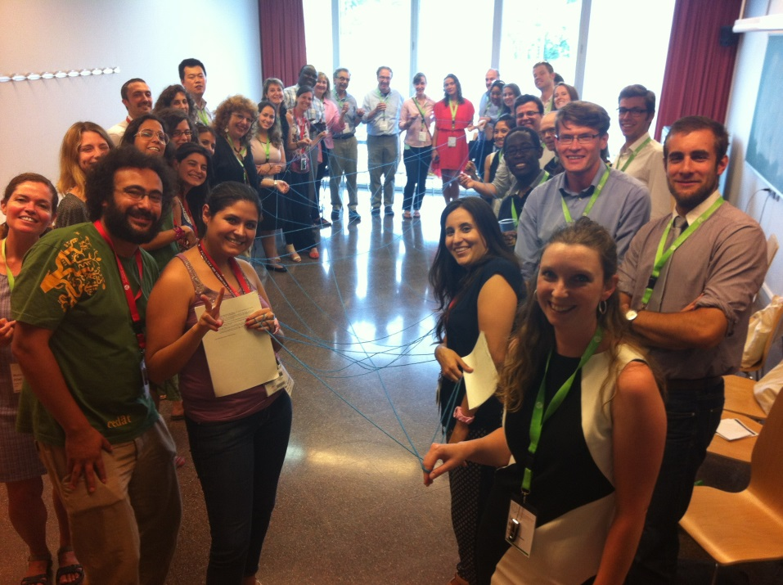
Graduate Students Forum during Tarragona Colloquium

The Academy publishes an electronic journal (eJournal), currently under the editorial guidance of Prof. Elizabeth Kirk and Prof. Amanda Kennedy, which notably provides detailed country reports on selected developments in national environmental law for the benefit of readers and researchers.
Academic support services activity has recently been extended to include translation of legal materials. Two specific projects are noteworthy:
Under the general supervision of the Secretariat, IUCN Academy of Environmental Law member institutions in France and in China are engaged in translation of on-line e-learning modules prepared by UNEP (InforMEA) in conjunction with relevant international convention secretariats. The modules will update and enhance accessibility to materials previously available in the Manual on International Environmental Law (2006) to which the Academy was an important contributor.
Draft Covenant
The latest version of the Draft Covenant on Environment and Development is currently being translated in French with the active participation of law students studying environmental law at the University of Ottawa. This project , used as pedagogical tool in a classroom setting over three years, has made it possible to introduce this progressive instrument to many law students during that period.
Appendix 1

ESSENTIALS READINGS IN ENVIRONMENTAL LAW: TOPICS
Agriculture, Food and Environmental Law at FAO - Mohamed Ali Mekouar, Faculty of Law, University of Casablanca, Morocco
Cambio climatico : participation de la Union europea en el régimen international - Mar Campins Eritja, Universitat de Barcelona, Espana
Climate Change Treaties - Melissa Powers, Lewis & Clark Law School, United States
Common but Differentiated Responsibility - Sumudu Atapattu, University of Wisconsin, United States
Compliance Mechanism in the Climate Change Regime - Meinhard Doelle, Dalhousie University, Canada
Corporate Social Responsibility and Environmental Law - Benjamin J. Richardson, University of British Columbia, Canada
The Deep Seabed and Environmental Law - Robin Warner, University of Wollongong, Australia
Derecho ambiental español - Jordi Jaria i Manzano, Universitat Rovira i Virgili, Espana
Emission Control in Nigeria and South Africa - Olugbenga Oke-Samuel, University of Zululand, South Africa
Environmental Law and ASEAN - Koh Kheng-Lian, National University of Singapore, Singapore
Environmental Law in Cameroon - Semie Memuna Sama, Ph.D. candidate, University of Ottawa, Canada
Environmental Law in the European Union - Ludwig Krämer, University of Bremen, Germany
Environmental Law in Indonesia - Mas Achmad Santosa, Founder, Indonesian Center for Environmental Law (ICEL); and Deputy Head, President’s Delivery Unit for Development Monitoring and Oversight, Indonesia, Josi Khatarina, senior legal staff of Indonesia REDD+ Agency, and Aldilla Stephanie Suwana, legal staff of Indonesia REDD+ Agency, Indonesia
Environmental Law in New Zealand - Trevor Daya-Winterbottom, University of Waikato, New Zealand
Environmental Law in Nigeria - Muhammed Tawfiq Ladan, Ahmadu Bello University, Nigeria
Environmental Law in Singapore - Lye Lin Heng, National University of Singapore, Singapore
Fresh Water Management and Environmental Law, Trevor Daya-Winterbottom, University of Waikato, New Zealand
German Environmental Law - Ludwig Krämer, University of Bremen, Germany
Global Environmental Governance - Nils Goeteyn, Ph.D. from Ghent University, Belgium
Health Impact Assessment (HIA) - Pamela Ko, The Sage Colleges, United States and Patricia E. Salkin, Touro Law Center, United States
History of Environmental Law (1) - Robert V. Percival, University of Maryland, United States
History of Environmental Law (2): Influencial Classics - Robert V. Percival, University of Maryland, USA
Human Rights and the Environment - Anna Grear, Cardiff University, United Kingdom
International Water Law – IUCN Environmental Law Centre, Bonn, Germany and Bjørn-Oliver Magsig, Helmholtz Centre for Environmental Research – UFZ, Leipzig, Germany
Invasive Species and Environmental Law - Sophie Riley, University of Technology, Sydney, Australia
Judgments of the European Union Court of Justice - Ludwig Krämer, University of Bremen, Germany
Land Grabbing in the Third World - Semie Memuna Sama, Ph.D. candidate, University of Ottawa, Canada
Marine Pollution from Land-based Sources: development of the regime - Naporn Popattanachai, Lecturer Faculty of Law, Thammasat University, Thailand, PhD Student School of Law University of Dundee, UK and Elizabeth A. Kirk, School of Law, University of Dundee, UK
Marine Pollution from Land-based Sources: specific and regional regimes - Naporn Popattanachai, Lecturer Faculty of Law, Thammasat University, Thailand, PhD Student School of Law University of Dundee, UK and Elizabeth A. Kirk, School of Law, University of Dundee, UK
Nile Negotiations - Emmanuel B. Kasimbazi, Makerere University, Uganda
Pêcheries africaines et convention des Nations Unis sur le droit de la mer - Yacouba Cisse, Université de Bouake, Côte d’Ivoire
Polar Regions and Environmental Law -Karen N. Scott, University of Canterbury, New Zealand and David L. VanderZwaag, Dalhousie University, Canada
Precautionary Principle - Angela Dwyer, University of Technology, Sydney, Australia
Protected Areas and Environmental Law - Alexander Paterson, University of Cape Town, South Africa
Resilience and Environmental Law - Tracy-Lynn Humby, Witwatersrand University, South Africa
Shipbreaking and Environmental Law - Saiful Karim, Queensland University of Technology, Australia
Sustainable Development Law - Andrea Ross, Dundee University, UK, and John C. Dernbach, Widener University, United States
Transboundary Protected Areas and Environmental Law - Elaine C. Hsiao, Ph.D. candidate, University of British Columbia, Canada
United States Environmental Criminal Law - Sarah Adams-Schoen, Touro College, USA
Vessel-Source Pollution and Environmental Law - Nengye Liu, Marie Curie Fellow, University of Dundee, UK
Voluntary Measures and Environmental Law - Andrew Lawson and Paul Martin, University of New England, Australia
Women and International Environmental Law - Linda A. Malone, William and Mary Law School, and Kang He, J.D. candidate at William and Mary Law School, United States
Women, Climate Justice and International Environmental Law - Linda A. Malone, William and Mary Law School, and Kang He, J.D. candidate at William and Mary Law School, United States
- See more at: http://www.iucnael.org/essentials-readings-in-environmental-law-topics#sthash.w3F4cFUP.dpuf

Appendix 2
CRITERIA FOR ENVIRONMENTAL LAW EDUCATION AWARDS, RESEARCH AWARDS AND ACADEMY FELLOWS

Education Awards
- Distinguished Environmental Law Education Award (Senior Scholar): an award for an individual with more than 10 years academic experience since the completion of his/her first law degree, from a Common Law or Civil Law jurisdiction, or, given that there are various legal systems around the world, law degrees from other comparable jurisdictions.

- Distinguished Environmental Law Education Award (Emerging Scholar): an award for an individual with less than 10 years academic experience since the completion of their first law degree.

“Academic experience” for purposes of the Environmental Law Education Award includes academic appointments such as lecturer, professor or similar positions, on a full-time or part-time basis.

Eligibility and Criteria
The Awards recognize achievements in the field of environmental law education, on a broad basis, rather than simply in connection with a nominee’s effectiveness as classroom teacher. Except in regard to official teaching awards, the quality of a nominee’s contribution to environmental law education as judged by student evaluations is not assessed because of methodological problems and privacy considerations. The Academy encourages nominations from all regions of the world, particularly from non-OECD countries.
The environmental law educational activities of the nominee may relate to “environmental law” in its broad understanding; i.e. not only traditional subjects of environmental law, such as pollution control and nature conservation, but also related subjects such as climate and energy law, natural resources law, corporate social responsibility, or environmental human rights.
Examples of educational contributions that may be considered include:
- Educational approaches that are innovative, intellectually rigorous, and engaging.
- Outstanding teaching of environmental law courses, at undergraduate or graduate-levels.
- Substantial curricula reform, such as designing or updating courses, as evidenced for example by new case studies, novel subject areas and innovative theoretical approaches.
- Initiating and / or managing a successful environmental law clinic, community internship or mooting program.
- Successful supervision of graduate students’ research, such as LLM theses and PhD dissertations.
- Publishing relevant educational materials, such as course textbooks, as well as scholarly articles about teaching strategies or learning methods.
- Mentoring and academic guidance of students, such as supervision of students hired as research assistants and other involvement of students in research projects.
- Educational and training activities for members of the legal profession, such as continuing legal education courses. .
- Strengthening teaching collaboration within and beyond the law school, such as through innovative electronic and Internet communications for delivering courses (e.g. video-conferencing and distance education) and promoting student exchange programs.
- Any other factors that demonstrate significant achievement in environmental law education.

Scholarship Awards
- The Emerging Scholar Award is presented to an academic with less than 10 years academic experience since the completion of their first law degree, from a Common Law or Civil Law jurisdiction, or, given that there are various legal systems around the world, law degrees from other comparable jurisdictions.

- The Senior Scholar Award is presented to an academic with more than 10 years academic experience since the completion of their first law degree.

Academic experience includes graduate-level research, post-doctoral positions and traditional academic appointments as lecturers, professors and similar positions.
Eligibility and Criteria
The primary consideration underlying these Awards is the quality or merit of the nominee’s published ‘scholarship’, including academic books (edited or authored), journal articles and book chapters, as well as commissioned policy reports and studies of research value. The scholarship could be published in any language. The Academy strongly encourages nominations from all regions in the world, particularly from non-OECD countries.
Consideration may also be given to other scholarly activities, such as:
- Editing an environmental law journal
- Organizing academic conferences and workshops
- Obtaining substantial research grants
- Building collaborative research networks, and
- Other innovations that advance research in environmental law.

Academy Fellows
The Candidates for appointment as a Fellow of the Academy must have provided exceptional service in the field of environmental law, over an extended period, in one or more of the following areas:
a) Academic distinction (as reflected in teaching and scholarly research outputs);
b) Environmental law practice (as reflected in distinguished and influential work in the practice of environmental law); or
c) Service to the field of environmental law (as reflected in distinguished and influential work in a judicial or administrative capacity or in the provision of community‐based services, including work in non‐governmental agencies).
A candidate’s service to the field of environmental law may be focused on the international, regional, national or local levels.

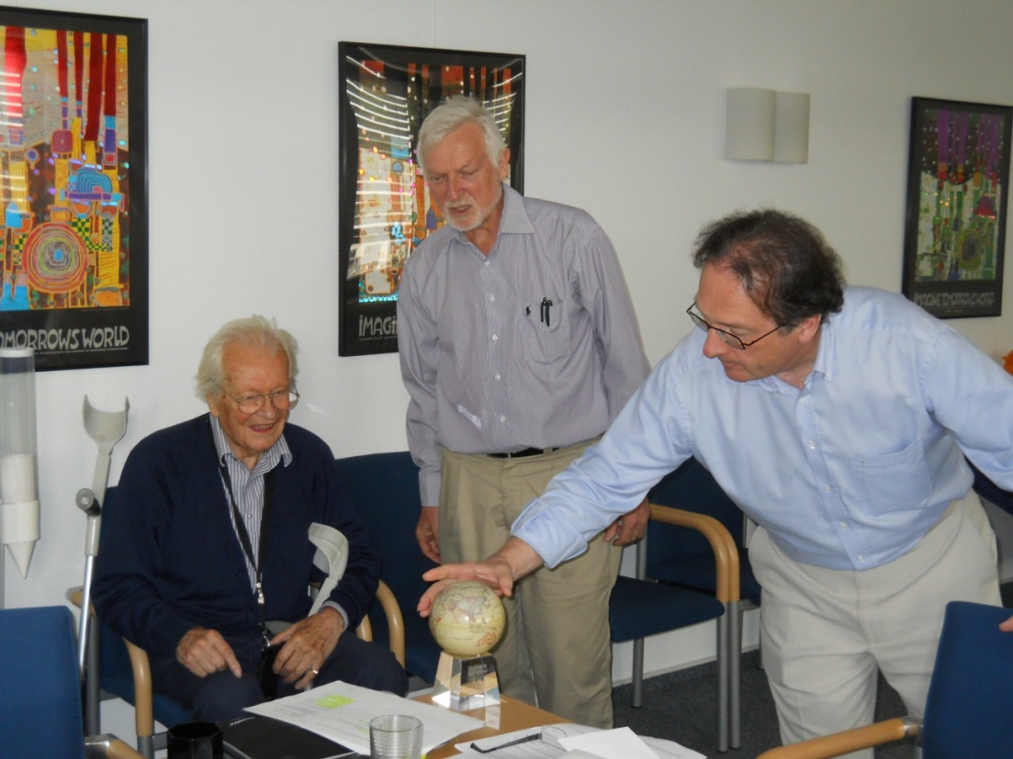

Dr. Wolfgang Burhenne was presented a MOVA Globe by Professors Jamie Benidickson and Ben Boer to mark the occasion of his appointment as a Fellow of the Academy

Appendix 3
IUCN ACADEMY OF ENVIRONMENTAL LAW PUBLICATIONS
IUCN Academy of Environmental Law Series (published by Edward Elgar Publishing)
Water and the Law Towards Sustainability
(Michael Kidd, Loretta Feris, Tumai Morumbo, Alejandro Iza eds. 2014)

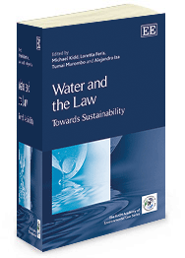

Global Environmental Law at a Crossroads
(Robert V. Percival, Jolene Lin, William Piermattei eds. 2014)

Biodiversity and Climate Change
(Frank Maes, An Cliquet, Willemein du Plessis, Heather McLeod-Kilmurray eds. 2013)
Local Climate Change Law - Environmental Regulation in Cities and Other Localities
(Benjamin J. Richardson, 2012)
Poverty Alleviation and Environmental Law
(Yves Le Bouthillier, Jose Juan Gonzalez-Marques, Albert Mumma, Susan Smith, Miriam Alfie Cohen eds. 2012)
Environmental Governance and Sustainability
(Paul Martin, Li Zhiping, Qin Tianbao, Anel de Plessis, Yves Le Bouthillier eds. 2012)

Compliance And Enforcement In Environmental Law
(Lee Paddock, Du Qun, Louis Kotze, David L. Markell, Kenneth J. Markovitz, Durwood Zaelke eds, 2011)

Environmental Law And Sustainability After Rio
(Jamie Benidickson, Ben Boer, Karen Morrow, Antonio Benjamin eds. 2011)

IUCN Academy Publications with Cambridge University Press

The following books have been published by Cambridge University Press since 2004 in collaboration with the IUCN Academy of Environmental Law:

Conservation, Law and Livelihoods: Bridging the North-South Divide
Edited by Michael Jeffrey, Karen Bubna-Litic and Jeremy Firestone, January 2008

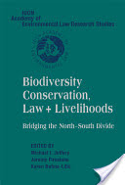

Land Use Law for Sustainable Development
Edited by Nathalie Chalifour, Patricia Kameri-Mbote, Lin Heng Lye and John Nolon, January 2006

Compendium of Land Use Laws
Edited by John Nolon, July 2006

The Law of Energy for Sustainable Development
Edited by Adrian J. Bradbrook, Rosemary Lyster, Richard L. Ottinger and Wang Xi, May 2005

Compendium of Sustainable Energy Laws
Edited by Richard L. Ottinger, Nicholas Robinson, and Victor Tafur, May 2005

For further information on the publications of the IUCN Academy of Environmental Law, please visit http://www.iucnael.org/en/academy-publications.html

